

This is ***your*** learning journal. Make sure that you keep it updated as you progress through the Project. Your teacher will let you know when to complete each step. Document your successes and failings as they provide the best learning opportunities!

To get started, please type your name in the following box:

|  |
| --- |
|  |

# 

# Step 1: Define

Please read through the Define content in your learning journal below, answering any questions that you find.

## Define the situation

Start by making sure that you watch the situation video on the platform: <http://app.createbase.co.nz/project/intro-to-programming/define>

After playing the video, work through this summary of the situation:

1. In this Project, a programmable humanoid robot (pictured below) has been built with the purpose of helping to improve people’s lives. How? By completing all sorts of day-to-day tasks. To achieve this design goal, the robot has been designed to perform similar movements to humans.

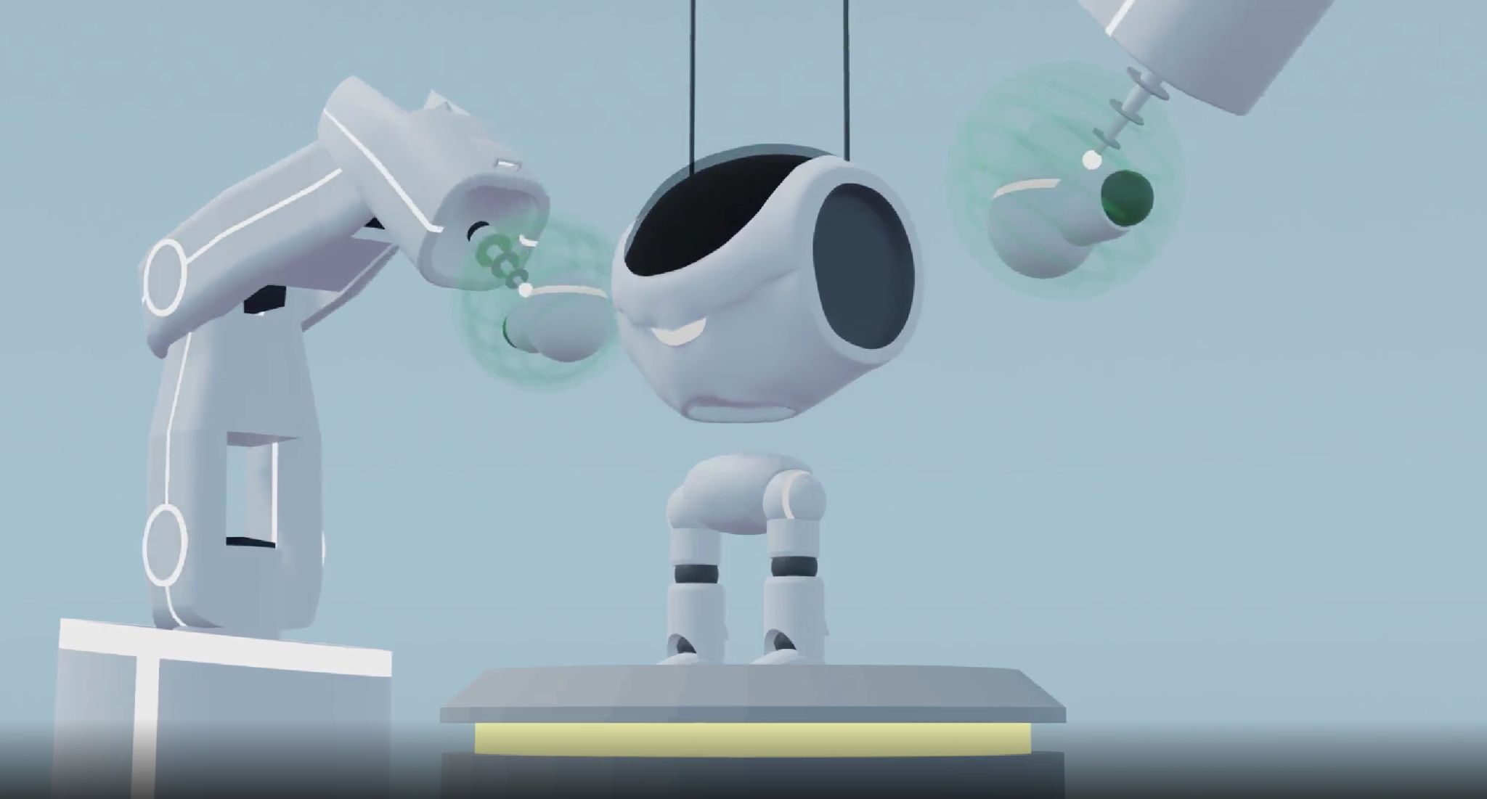 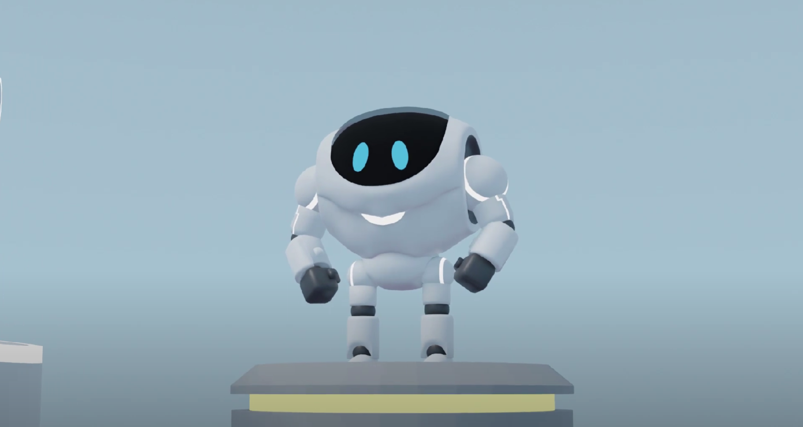

1. The robot can be controlled by writing and uploading programs to it.

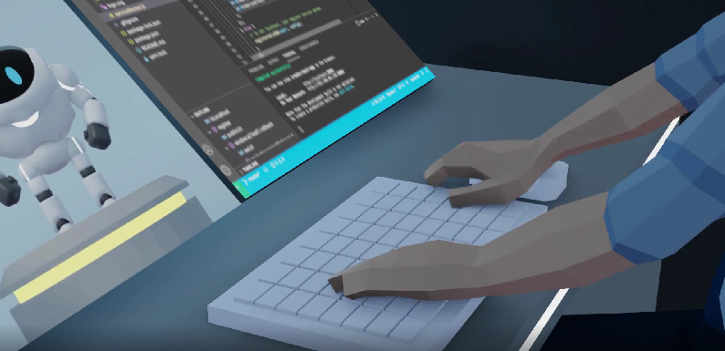

Do you know what a program is? If you do, try and describe it below using one or two sentences. *Don’t worry if you can’t; we will go over it in the Imagine step.*

|  |
| --- |
|  |

1. The robot is being put through a series of tests to make sure that the design is physically capable of performing a wide variety of tasks without breaking. For each test, somebody seems to be programming the robot. Whenever the robot fails, the code is updated until the test is passed.

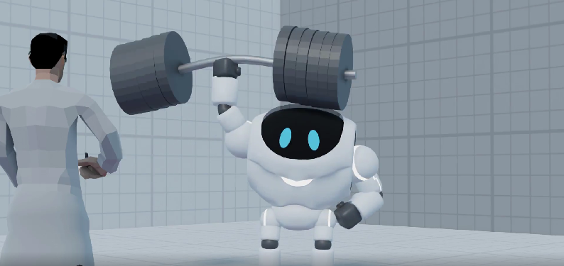

1. Once the robot completes all of the tests, it progresses to stage 2 of testing.

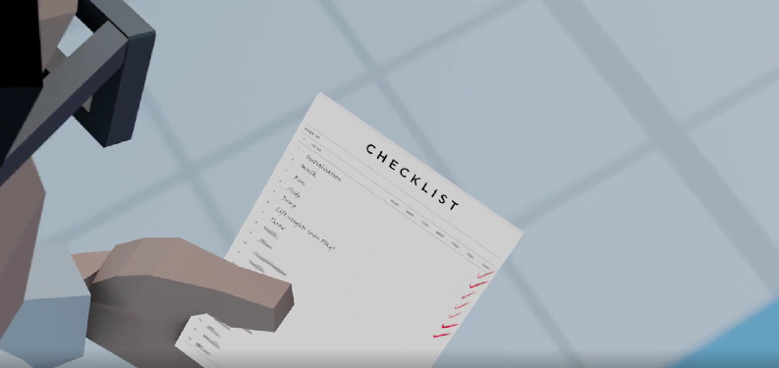 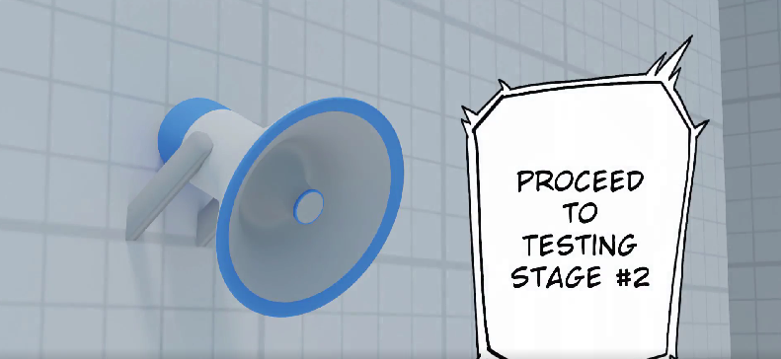

## Define the problem

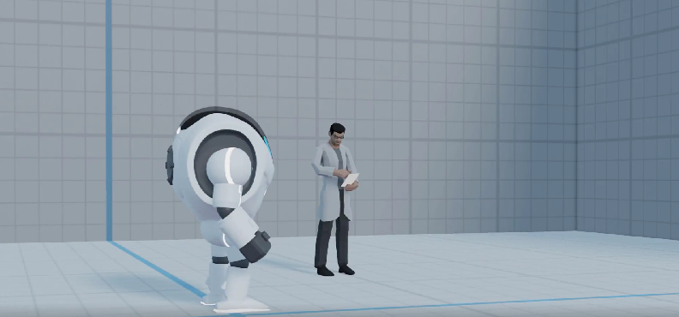

The robot has already passed the first round of tests, but it now needs to pass the second round before it is ready to be sent out into the world.

As part of quality assurance, it is your job to write a series of programs to make the robot perform the actions required for each test in the second round. If the robot can pass all the tests successfully (without breaking), it will be marked as ready to release into the world to help people carry out everyday tasks. It may be especially useful for individuals whose unique situations make it difficult to perform specific physical tasks.

Programming? Automation? Move on to Step 2: Imagine to learn more about the solution you will be building.

# Step 2: Imagine

Read the content in the *Demystifying programming* card on the platform, then return to your learning journal and answer the following questions. If you are working in a group, discuss all of your answers as a team, but make sure that every member writes a summary in their own learning journal. Bullet points and incomplete sentences are acceptable.

1. Based on the information on the platform, give a brief description of what programming is in your own words.

|  |
| --- |
|  |

Read the *Application: automation* card on the platform, then return to your learning journal and answer the following questions.

1. Based on the information on the platform, give a brief description of what automation is in your own words.

|  |
| --- |
|  |

1. List three tasks that you would love to have automated in your own life. For each one, briefly explain the advantages (what you will gain) by having this task automated.

|  |
| --- |
|  |

1. Choose one of the tasks from question 3. Briefly describe each of the steps that a robot or software would have to undertake to complete the task.

|  |
| --- |
|  |

1. Using your answer to question 4, list three problems that a robot or software automating this task might encounter. Problems could involve difficult decisions, lots of edge cases or information that is hard to measure.

|  |
| --- |
|  |

1. By writing a few sentences, briefly describe how you think technology will impact your life in ~20 years. For example, think about everyday tasks in your life right now. How might the way you carry out these tasks change as technology improves? Would they get easier? Would they disappear? Would new tasks replace them?

|  |
| --- |
|  |

Read the content in the *Your mission* card, then return to this learning journal and scroll down to the Create step.

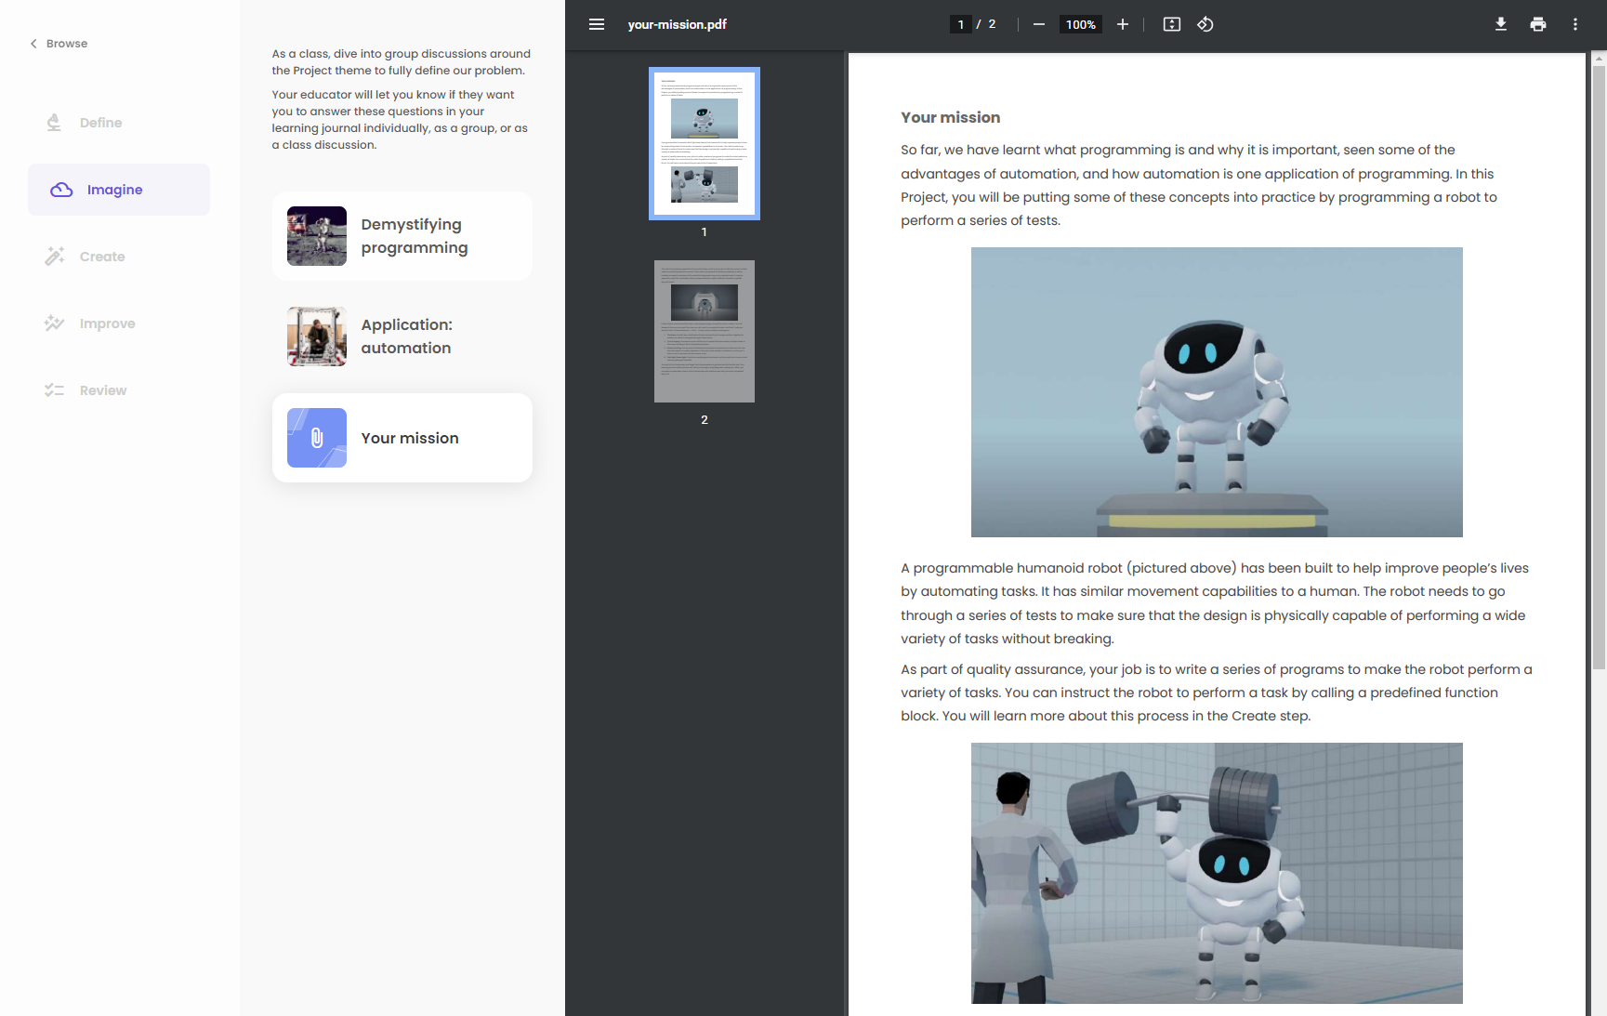

# 

# Step 3: Create

## Subsystem 1: The Maze

Each of the tests your robot needs to pass are designed to mimic a real-life scenario.

In the first subsystem, the scenario is that a building has caught on fire, and a cat is trapped at the end of a hallway! It is too dangerous to send people inside, so we will send the robot instead.

Unfortunately, there is no clear path to the cat through the building as some doors are still locked. Luckily, some of the walls have been weakened by the fire. The robot is strong enough to break these weakened walls with a single punch!

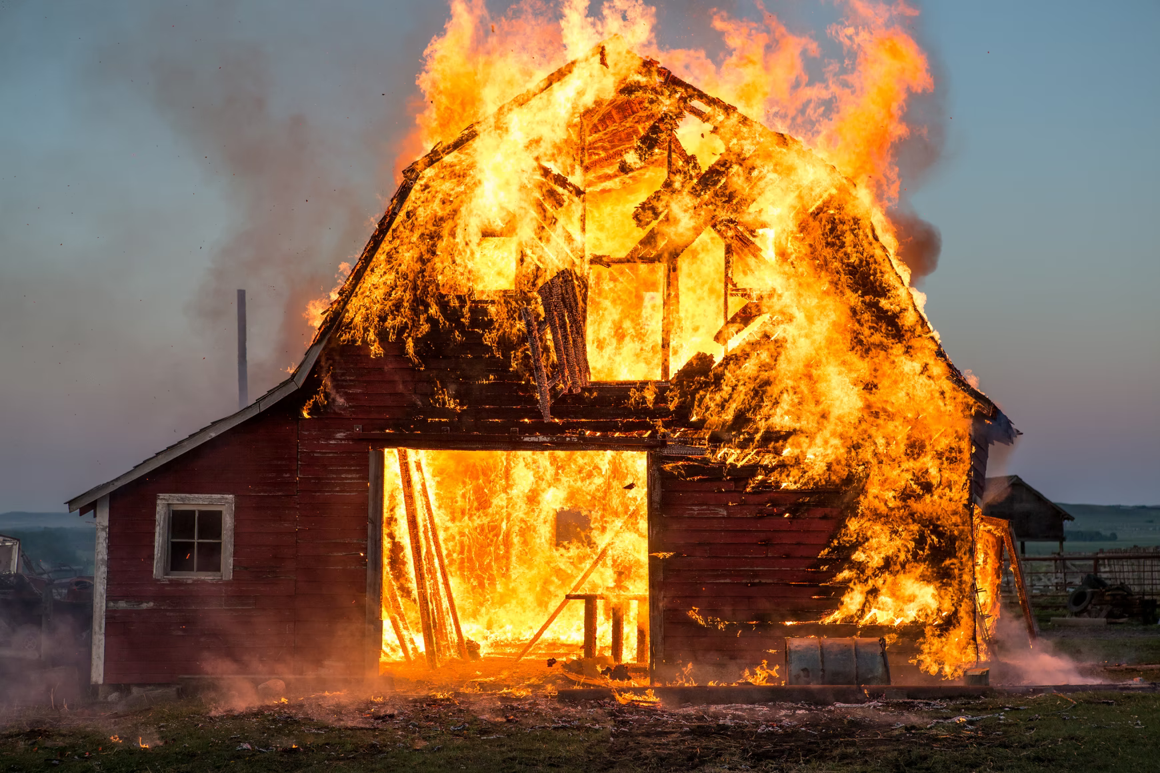 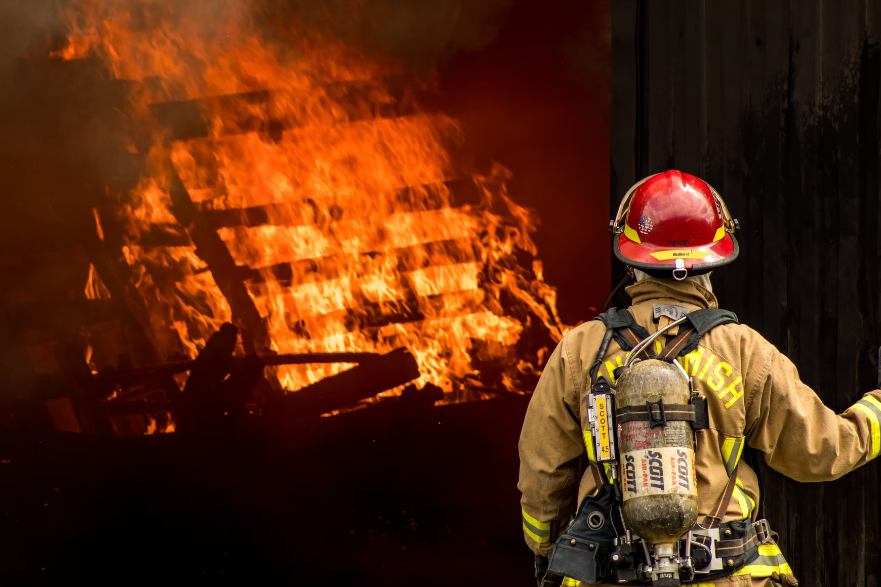

Your job is to test the robot’s ability to complete a series of straightforward instructions to reach the end of a maze that mimics the layout of this burning building. To get started, navigate to the Create step and start the first subsystem. You will then be able to read or watch each of the Research cards, returning to this learning journal to answer some questions at the end of each one.

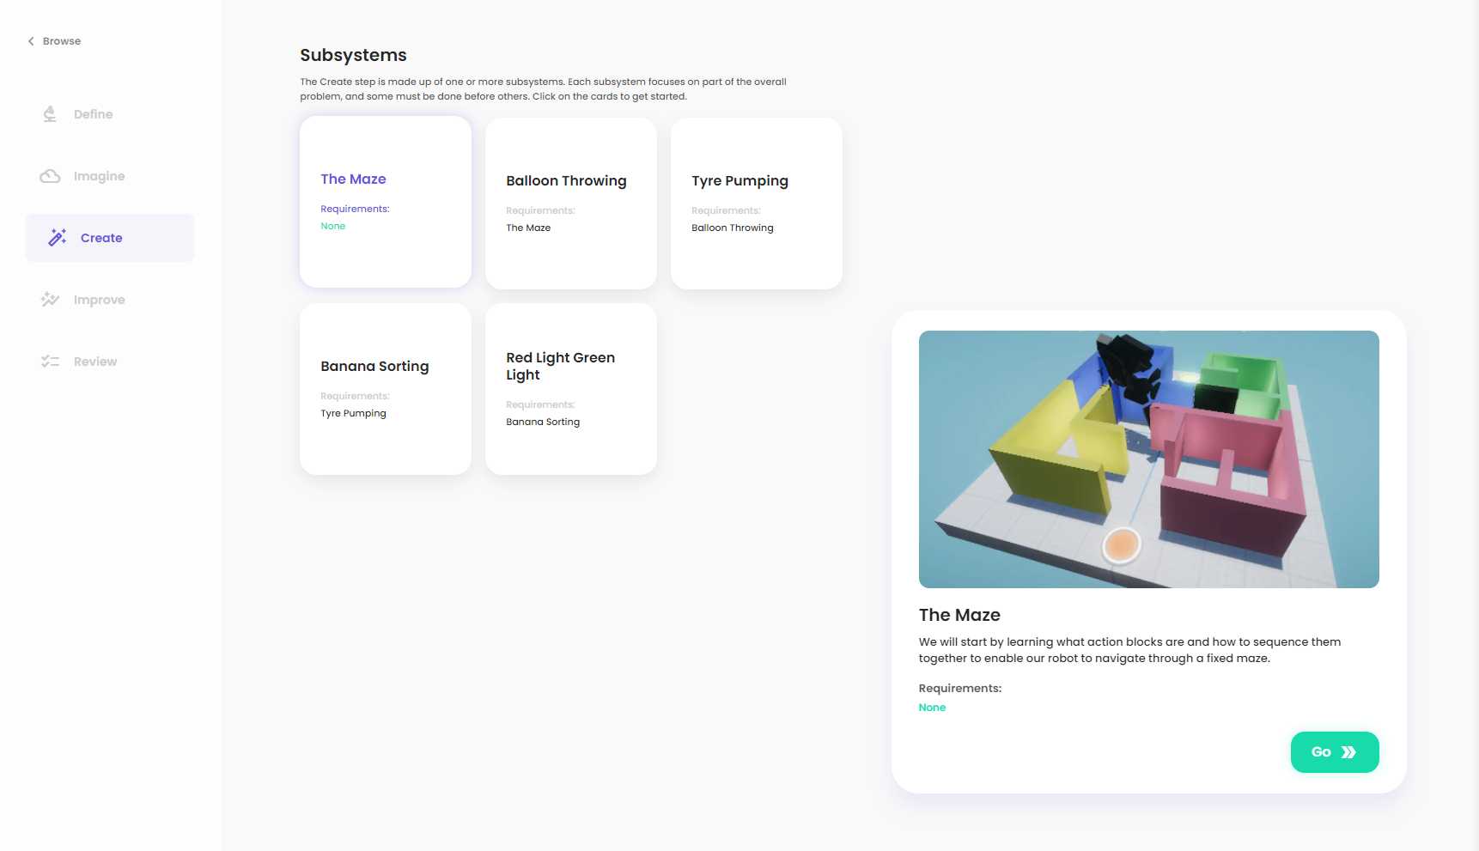

### Research

Read the content in the *Intro to functions* card and then answer the following questions. Feel free to discuss the content of the card with your classmates.

1. In your own words, give a brief description of what a function is and why they might be useful to programmers.

|  |
| --- |
|  |

1. In your own words, describe what *sequentially* means.

|  |
| --- |
|  |

1. How many action blocks can be running at the same time?

|  |
| --- |
|  |

Read the content in the *Flow: Action blocks* card. You may want to refer to this pdf as you create your Code answer.There are no immediate questions to answer for this card.

Watch the *Flow: Editor tutorial* video if you have never used the Flow programming language before. Alternatively, your teacher may play it once for the entire class. There are no immediate questions to answer for this card.

That's it for Research. You can now move on to Plan:

### Plan

In this step, our aim is to understand how we could move the robot through the maze by creating a sequence of action blocks. To program the robot to complete this test, you only need to be able to answer four questions:

1. What does each action block make the robot do?

*You can figure this out by reading the Research content or trial and error in the Code step.*

1. What are the different obstacles that the robot could encounter?

*In the Code step, start by figuring out the correct path to reach the end. Remember that the badly burnt walls can be broken with a robot punch.*

1. For each obstacle, what is the correct action for the robot?

*The robot can only perform one action at a time and will perform them in the same order indicated by the orange arrows. You need to figure out the correct order of action blocks to reach the end of the maze. This might involve trial and error.*

1. How do I connect blocks together?

*Drag from the solid orange output handle of one block to the hollow orange input handle of another.*

You don’t need to write down any answers to these questions. Instead, once you have read them, you can continue to the Code step below:

### Code

Return to the platform and create your answer using the simulation inside the Code step. Make sure that you refer back to the Research and Plan content in your learning journal or the platform whenever you get stuck!

To test your program, press the compile button. Don’t wait until you have a finished program before compiling. It is very common to keep testing as you slowly build your answer while coding because it is often easier to fix problems as they happen rather than going back at the end.

When you have finished writing your code, add a screenshot of your final solution below, showing the success screen and your Flow code.

Importan**t**: *you can save your Flow code using the save icon () in the toolbar in the bottom left corner of the Flow editor. If you save your code before you leave the simulation, you will be able to continue where you left off when you return by pressing the restore icon directly below the save icon.*

|  |
| --- |
|  |

You can now move on to the next subsystem.

## 

## Subsystem 2: Balloon Throwing

Try and throw any object five times and hit the **exact** same target a reasonable distance away. Unless you have a lot of practice, this is probably pretty difficult. Why? Because where your thrown object lands depend on factors like the power and aim of your throw - things that are pretty hard for humans to remember and copy the same every time.

One of the advantages of automation is that robotic systems can easily repeat the same task multiple times the exact same way. Therefore, if we want extreme consistency in how we throw an item, using a robot instead of a human might be a good idea.

  

In this second subsystem, a water balloon fight has broken out (is that still a thing these days?)! Rather than throw them ourselves though, we are going to program the robot to throw the water balloons for us to get greater accuracy and more power.

This test will assess the robot’s ability to use sensors and perform actions with varying power levels. To get started, return to the Create step and start the second subsystem. You will then be able to read each of the Research cards, returning to this learning journal to answer some questions at the end of each one.

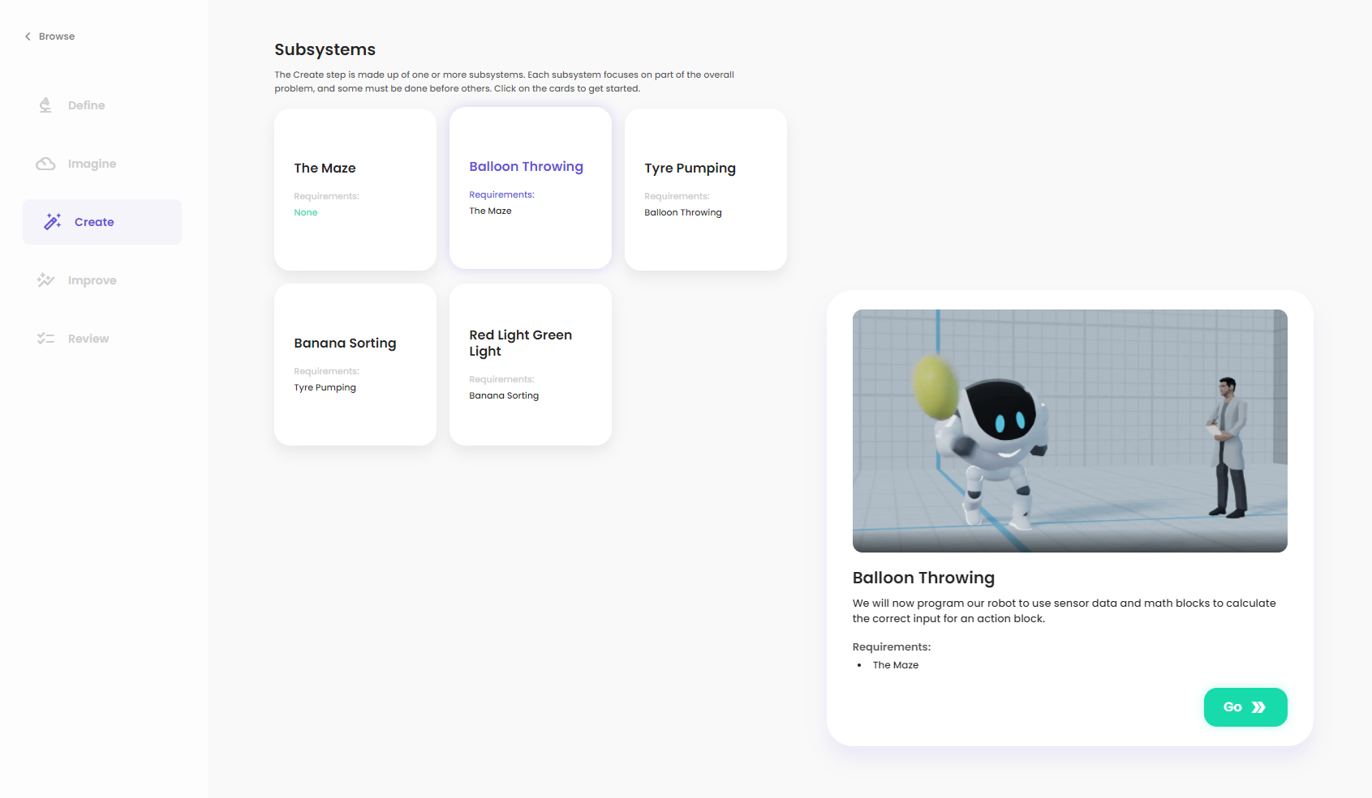

### Research

Read the content in the *Flow: Sensor blocks* card and then answer the following questions. Feel free to discuss the content of the card with your classmates.

1. In your own words, give a brief description of what a sensor is and why they are an essential part of robotics.

|  |
| --- |
|  |

1. List at least three natural sensors. For each one, describe the information that it measures.

|  |
| --- |
|  |

1. List at least three manufactured sensors. For each one, describe the information that it measures.

|  |
| --- |
|  |

Read the content in the *Flow: Operation blocks* card. You may want to refer to this pdf as you create your code answer.There are no immediate questions to answer for this card.

That's it for Research. You can now move on to Plan:

### Plan

In this step, our aim is to create a plan for how our robot could use sensors and operation blocks to calculate the correct power to throw the balloon. To do this, let’s try to answer the following questions.

In this test, your job is basically to re-create the following equation using Flow blocks:

$$Power=ThrowConstant\frac{D}{\sqrt{D+1.7}}$$

Once you have calculated the correct power, plug that value into the input to the Throw Balloon block and compile your code.

1. For each of the terms in the equation, what block(s) do you think you will use? What are the inputs and outputs to that block? One block is already done for you.

|  |
| --- |
| *I will use the sqrt block to perform the square root operation. The input will be the number to square root (D + 1.7), and the output will be the resulting number.* |

Once you have an idea of the blocks you will use, proceed to Code:

### Code

Return to the platform and create your answer using the simulation inside the Code step. Make sure that you refer back to the Research and Plan content in your learning journal or the platform whenever you get stuck!

To test your program, press the compile button.

When you have finished creating your answer, add a screenshot of your final solution below, showing the success screen and your Flow code.

Importan**t**: *you can save your Flow code using the save icon () in the toolbar in the bottom left corner of the Flow editor. If you save your code before you leave the simulation, you will be able to continue where you left off when you return by pressing the restore icon directly below the save icon.*

|  |
| --- |
|  |

You can now move on to the next subsystem.

# 

## Subsystem 3: Tyre Pumping

Oh no! You are driving along, and your tyre gets destroyed! Luckily, you have a spare tyre in the back of your car. Unfortunately, it has no air in it. To get a smooth ride and make sure that this spare tyre doesn’t also get destroyed, you need to fill it up with air. However, trying to inflate a car tyre manually can take forever. If you are older or have a physical injury, this may be even harder.

A robot, however, will have no complaints while carrying out such a task. Robotics and automation can be especially helpful for people who have difficulties with physically demanding tasks.

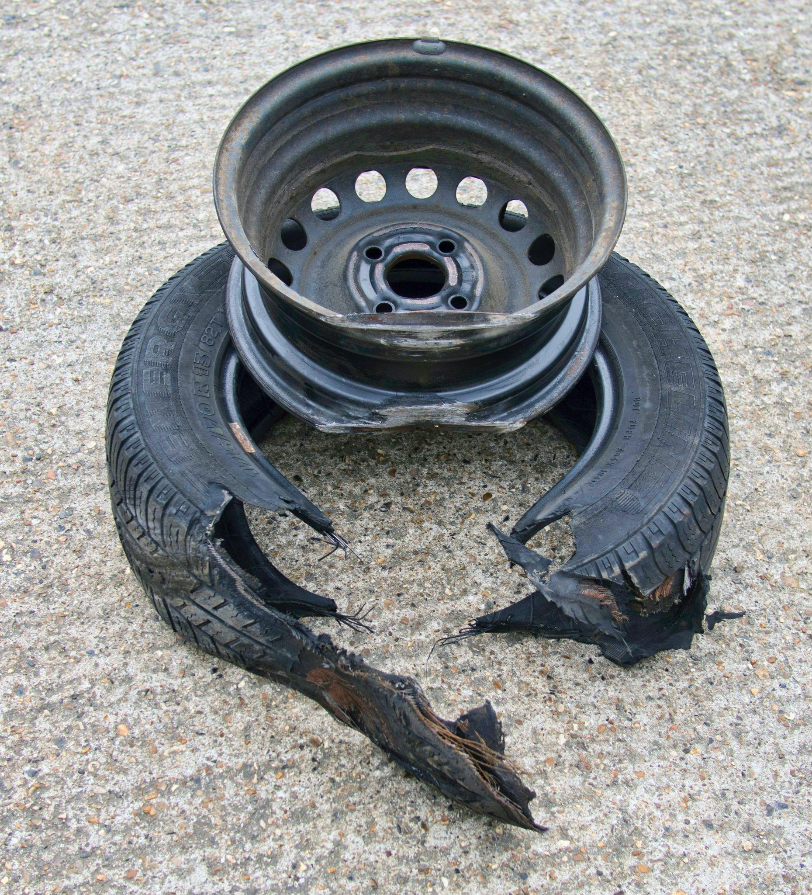 

In this third subsystem, we will be testing the strength and endurance of the robot by having it inflate a tyre to the correct pressure.

To get started, return to the Create step and start the third subsystem. You will then be able to read each of the Research cards, returning to this learning journal to answer some questions at the end of each one.

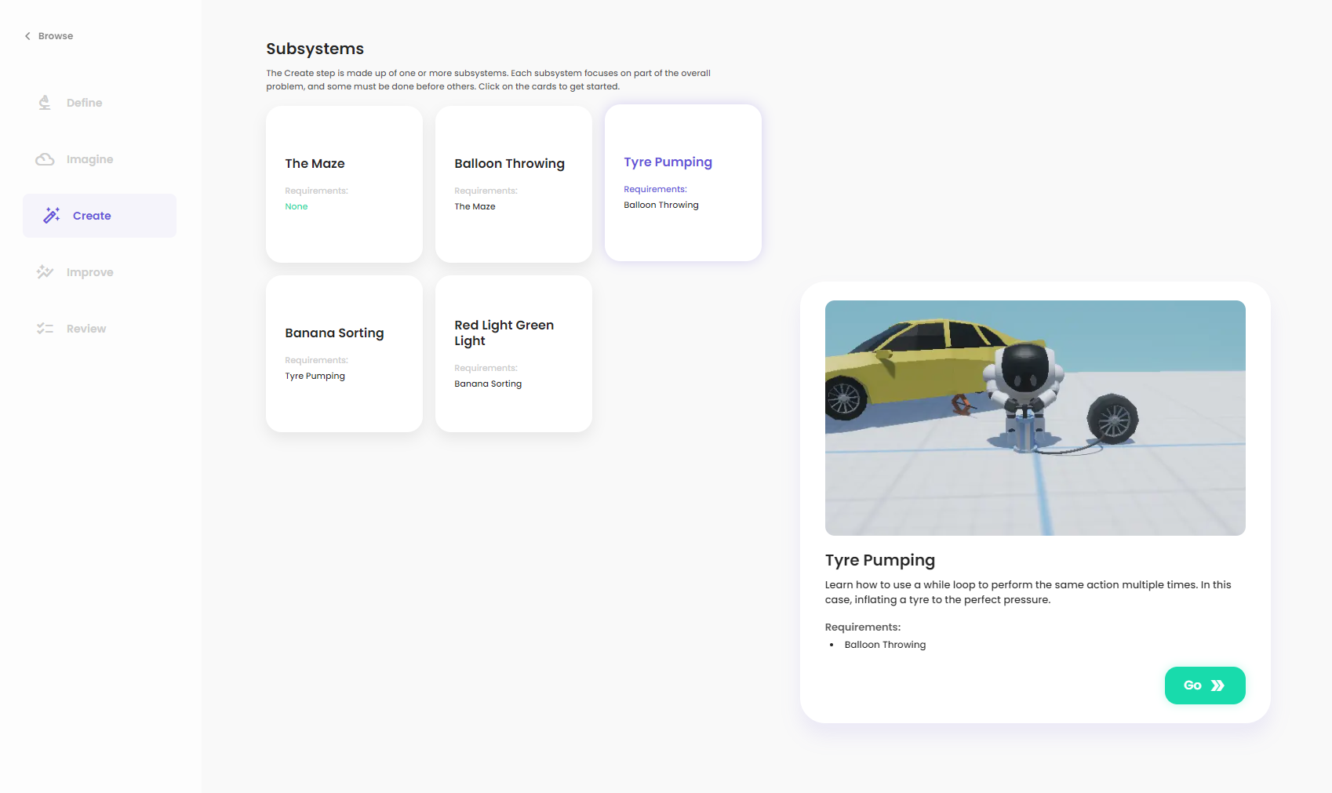

### Research

Read the content in the *Flow: Comparison blocks* card and then answer the following questions. Feel free to discuss the content of the card with your classmates.

1. In your own words, give a brief description of a comparison statement and provide examples of where comparison statements might be used, both in real life and in a program.

|  |
| --- |
|  |

Read the *Flow: While blocks* card and then answer the following questions. Feel free to discuss the content of the card with your classmates.

1. In your own words, give a brief description of a while loop.

|  |
| --- |
|  |

1. List at least two advantages to using while loops while programming.

|  |
| --- |
|  |

1. In the microphone example on the platform, what would happen if we pressed compile while our microphone was detecting no sounds? If our microphone started detecting sounds at some point in the future (but we didn't re-compile), what would happen and why?

|  |
| --- |
|  |

That's it for Research. You can now move on to Plan:

### Plan

In this test, our robot needs to use a pump to inflate a tyre. Our robot has access to a sensor that measures the tyre's current pressure. We can access the latest value of this sensor using the Get Tyre Pressure block. This block outputs the current tyre pressure in psi (pound-force per square inch). To program the robot to complete this test, you need to keep pumping the tyre until it reaches the correct pressure (32 psi).

1. How will the robot know when to stop inflating the tyre?

|  |
| --- |
| *When the tyre pressure reaches 32 psi.* |

1. How will it know what the current tyre pressure is?

|  |
| --- |
| *By using the Get Tyre Pressure sensor.* |

Continue to the Code step below:

### Code

Return to the platform and create your answer using the simulation inside the Code step. Make sure that you refer back to the Research and Plan content in your learning journal or the platform whenever you get stuck!

To test your program, press the compile button.

When you have finished creating your answer, add a screenshot of your final solution below, showing the success screen and your Flow code. Then, write a brief explanation of how it works, including any problems you encountered along the way and how you overcame them.

Importan**t**: *you can save your Flow code using the save icon () in the toolbar in the bottom left corner of the Flow editor. If you save your code before you leave the simulation, you will be able to continue where you left off when you return by pressing the restore icon directly below the save icon.*

|  |
| --- |
|  |

You can now move on to the next subsystem.

# 

## Subsystem 4: Banana Sorting

*Bananas, ooh ya-ya. We have to sort some bananas, ooh na-na. Should we sort with a human, na-na-na. Or maybe with a robot? That’d be an improvement. Bananas, ooh ya-ya.*

In this scenario, we are stepping inside a banana sorting plant. Recently picked bananas come onto a roller conveyor and need to be sorted into the correct crate based on their ripeness. The colour of a banana determines its ripeness. Bananas that are entirely green or have any brown need to be sorted into the red create, while all other types need to be sorted into the green crate.

Sorting bananas can be a boring task, making it easy for humans to lose focus and make a mistake. Therefore, we will be attempting to automate this task using our humanoid robot.

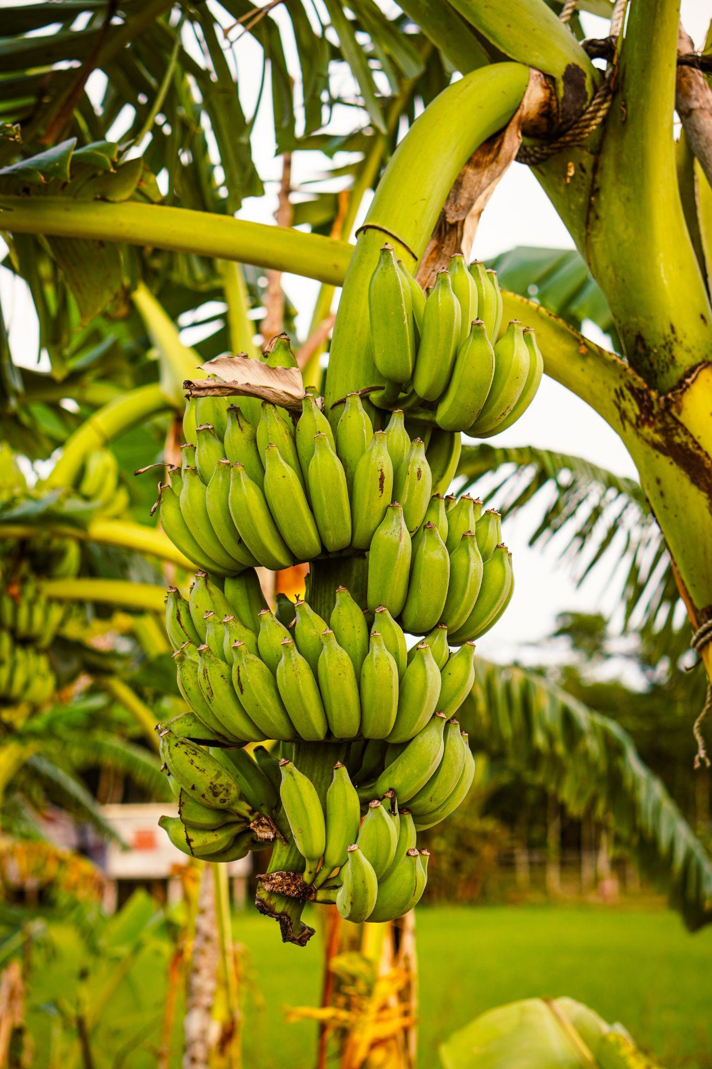 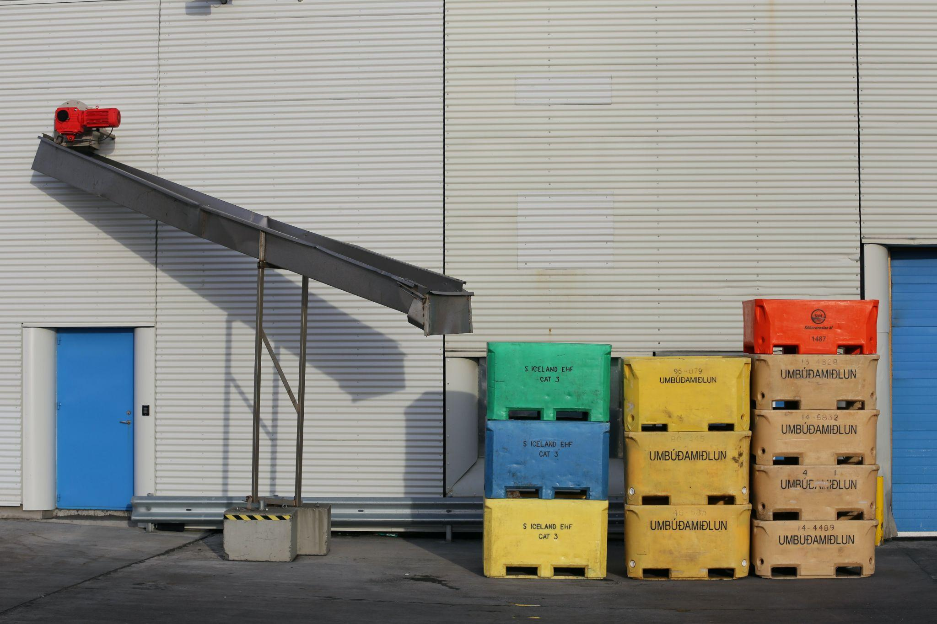 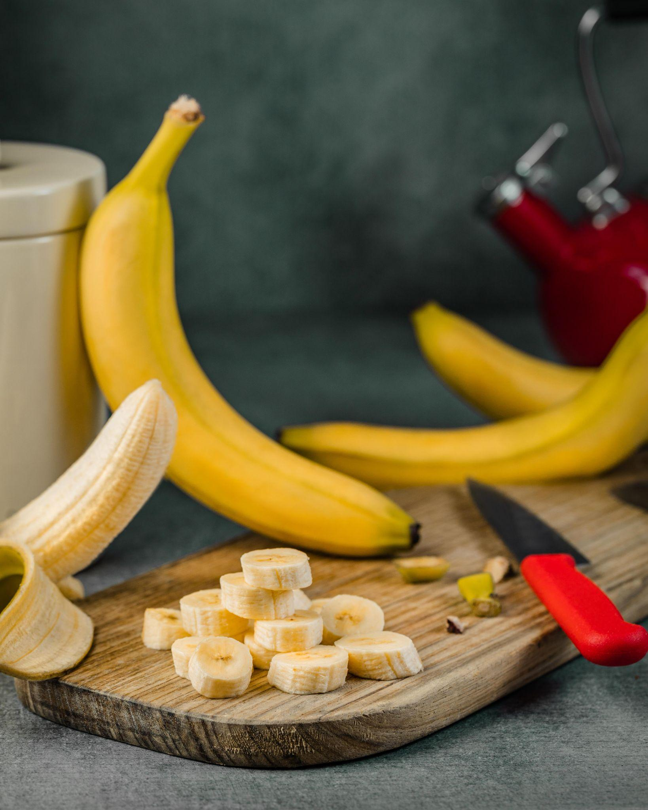

In this fourth subsystem, we will be testing the ability of the robot to make decisions based on logic. The robot needs to identify the colour of the banana and then change the direction of the roller conveyor to make sure that the banana ends up in the correct crate.

To get started, return to the Create step and start the fourth subsystem. You will then be able to read each of the Research cards, returning to this learning journal to answer some questions at the end of each one.

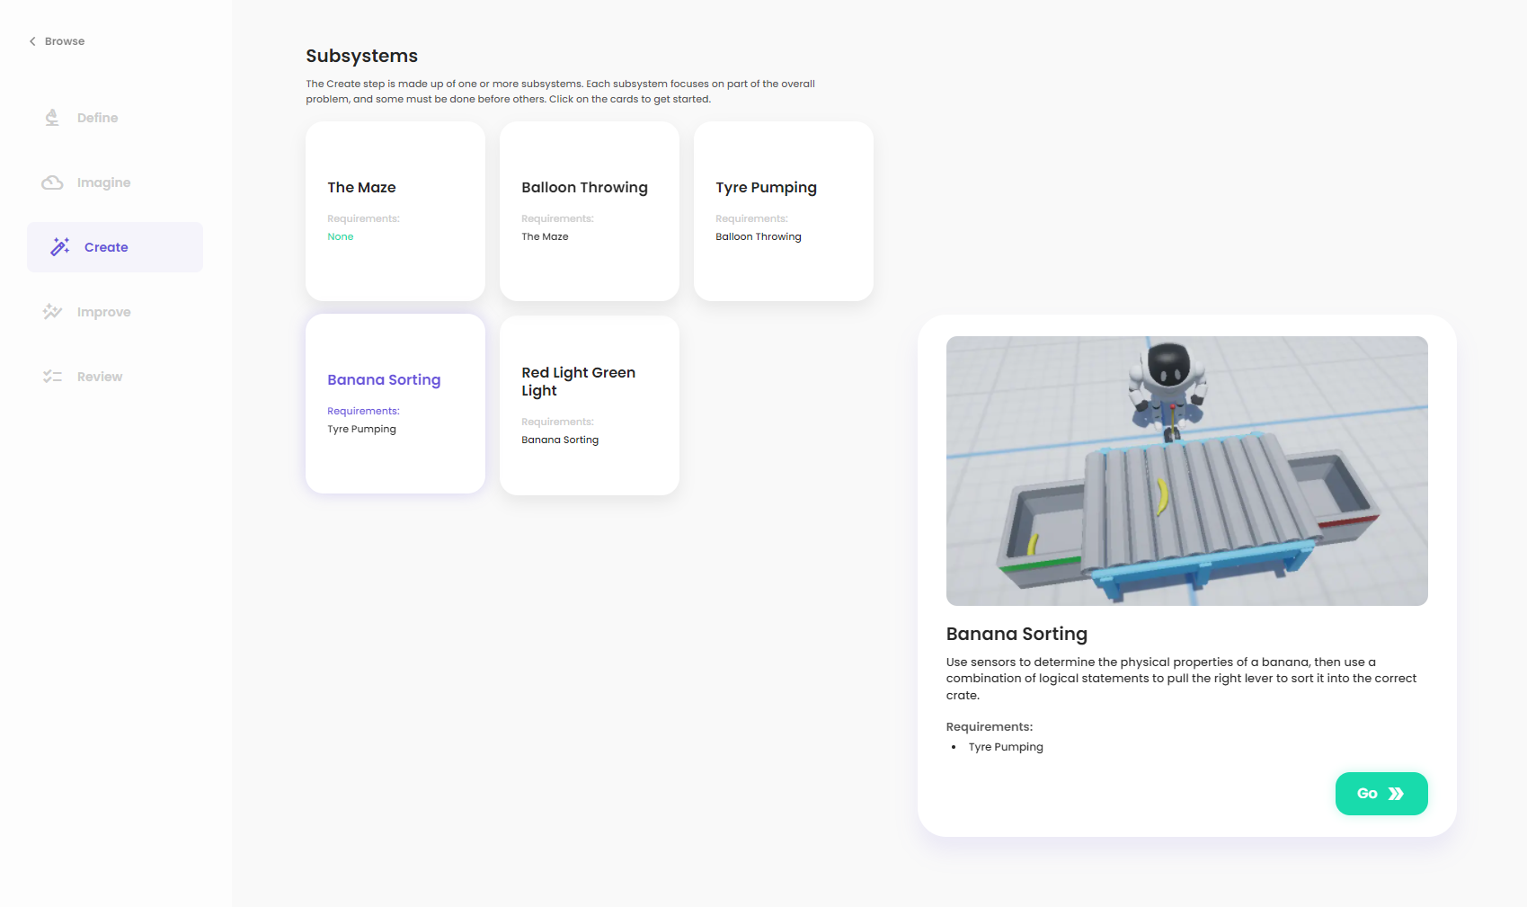

### Research

Read the content in the *Flow: Boolean & logical blocks* card and then answer the following questions. Feel free to discuss the content of the card with your classmates.

1. For each of the following logical statements, what would the output be?
   1. True AND false

|  |
| --- |
|  |

* 1. True OR true

|  |
| --- |
|  |

* 1. False AND false

|  |
| --- |
|  |

* 1. True OR false

|  |
| --- |
|  |

* 1. NOT true

|  |
| --- |
|  |

* 1. NOT (5<3)

|  |
| --- |
|  |

* 1. (5 < 5) AND true

|  |
| --- |
|  |

* 1. (23>5) AND (2<3)

|  |
| --- |
|  |

* 1. (4>5) OR true

|  |
| --- |
|  |

* 1. (5>5) AND (1 < 7)

|  |
| --- |
|  |

* 1. NOT ((true) AND (8 < 8))

|  |
| --- |
|  |

* 1. NOT ((5 > 6) OR (8 < 8))

|  |
| --- |
|  |

Read the *Flow: Banana sorting* card and then answer the following questions. Feel free to discuss the content of the card with your classmates.

1. Each colour of light has a unique physical property called a wavelength. For example, blue light has a wavelength of approximately 450 nanometres, whereas green light has a wavelength of around 550 nanometres. There are sensors that can detect if light contains a particular wavelength. Describe how these sensors could be used to determine the colour of a banana.

|  |
| --- |
|  |

1. In this test, we want our robot to keep checking the colour of incoming bananas. Describe how we could use a while block to infinitely check the colour of bananas.

|  |
| --- |
|  |

That's it for Research. You can now move on to Plan:

### Plan

In this test, you will need to take the boolean outputs from the three colour sensors and then combine them using logical blocks into a single boolean to use as the input for the Pull Lever action block.

Remember that when the input to Pull Lever is TRUE, the banana will be sent to the red crate. When the input to Pull Lever is FALSE, the banana will be sent to the green crate. Bananas that are fully yellow or half yellow/green need to be sent to the green crate. All other colour combinations need to be sent to the red crate.

1. For each of the banana colours in the following table, write the expected output of each of the sensors and the final value that you want to use as input for the Pull Lever block. The first and last rows are done for you.

|  |  |  |  |  |
| --- | --- | --- | --- | --- |
| Banana colour | Get Banana Green | Get Banana Yellow | Get Banana Brown | Pull Lever |
| Green | TRUE | FALSE | FALSE | TRUE |
| Yellow |  |  |  |  |
| Brown |  |  |  |  |
| Green and yellow |  |  |  |  |
| Green and brown |  |  |  |  |
| Yellow and brown | FALSE | TRUE | TRUE | TRUE |

1. Could we connect the output of the Get Banana Yellow sensor directly to the Pull Lever block? Why or why not? Hint: use your table in question 1 to look for any cases where a banana would be sorted incorrectly.

|  |
| --- |
|  |

If we only wanted Pull Lever to be TRUE when the banana was yellow and brown, we could connect a logical statement like this to its input:

NOT(Get Banana Green) AND (Get Banana Yellow) AND (Get Banana Brown)

1. Using the logical statement above, what boolean value would be passed into the Pull Lever action block for each of the banana colours? Columns 2, 3 and 4 should be the same as your completed table from question 1, but the fifth column will be different.

|  |  |  |  |  |
| --- | --- | --- | --- | --- |
| Banana colour | Get Banana Green | Get Banana Yellow | Get Banana Brown | Pull Lever |
| Green | TRUE | FALSE | FALSE |  |
| Yellow |  |  |  |  |
| Brown |  |  |  |  |
| Green and yellow |  |  |  |  |
| Green and brown |  |  |  |  |
| Yellow and brown | FALSE | TRUE | TRUE |  |

You can see that if we used the logical statement above, we would be passing incorrect booleans to the Pull Lever action block. Your task is to find a logical statement like the one above that results in the correct booleans in the final column (they should be the same as the final column of question 1).

The Pull Lever block should have an input of TRUE if the sensors indicate that the banana is only yellow OR if the sensors indicate that the banana is yellow and green.

In other words, the Pull Lever block should have an input of FALSE if the sensors indicate that the banana is fully green OR if the sensors indicate that the banana has any amount of brown.

When you feel confident, continue to the Code step below to test your logical statement:

### Code

Return to the platform and create your answer using the simulation inside the Code step. Make sure that you refer back to the Research and Plan content in your learning journal or the platform whenever you get stuck!

To test your program, press the compile button.

When you have finished creating your answer, add a screenshot of your final solution below, showing the success screen and your Flow code. Then, write a brief explanation of how it works, including any problems you encountered along the way and how you overcame them.

Importan**t**: *you can save your Flow code using the save icon () in the toolbar in the bottom left corner of the Flow editor. If you save your code before you leave the simulation, you will be able to continue where you left off when you return by pressing the restore icon directly below the save icon.*

|  |
| --- |
|  |

You can now move on to the final subsystem in Create.

# 

## Subsystem 5: Red Light Green Light

Although robots can help us perform tasks more efficiently, they also have the potential to help people compensate for or overcome physical limitations.

In this scenario, our robot has been tasked with assisting a visually impaired person with crossing the road. The robot will need to use a sensor to detect the colour of the traffic light and only cross the road while the light is green.

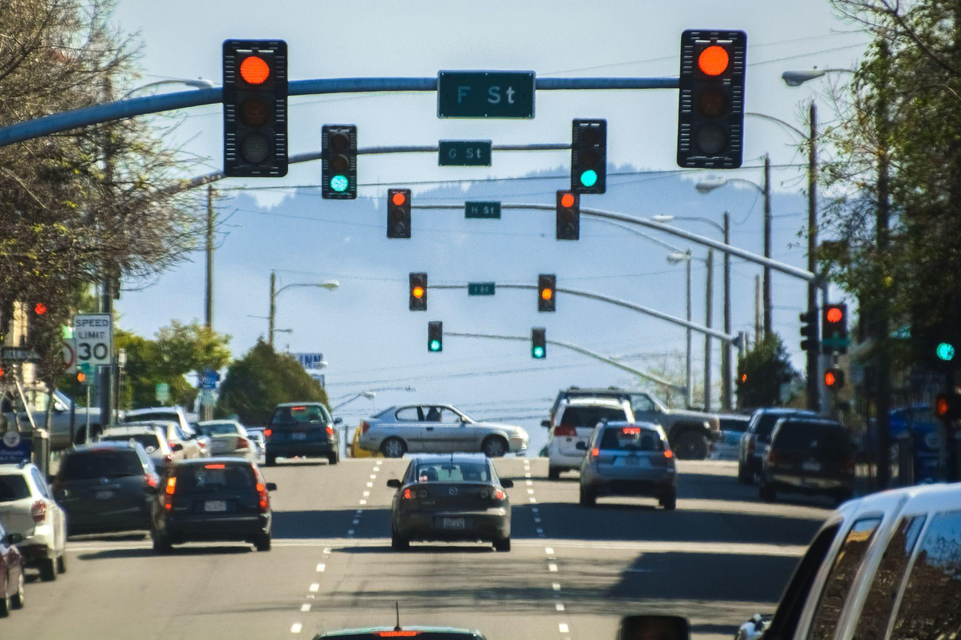 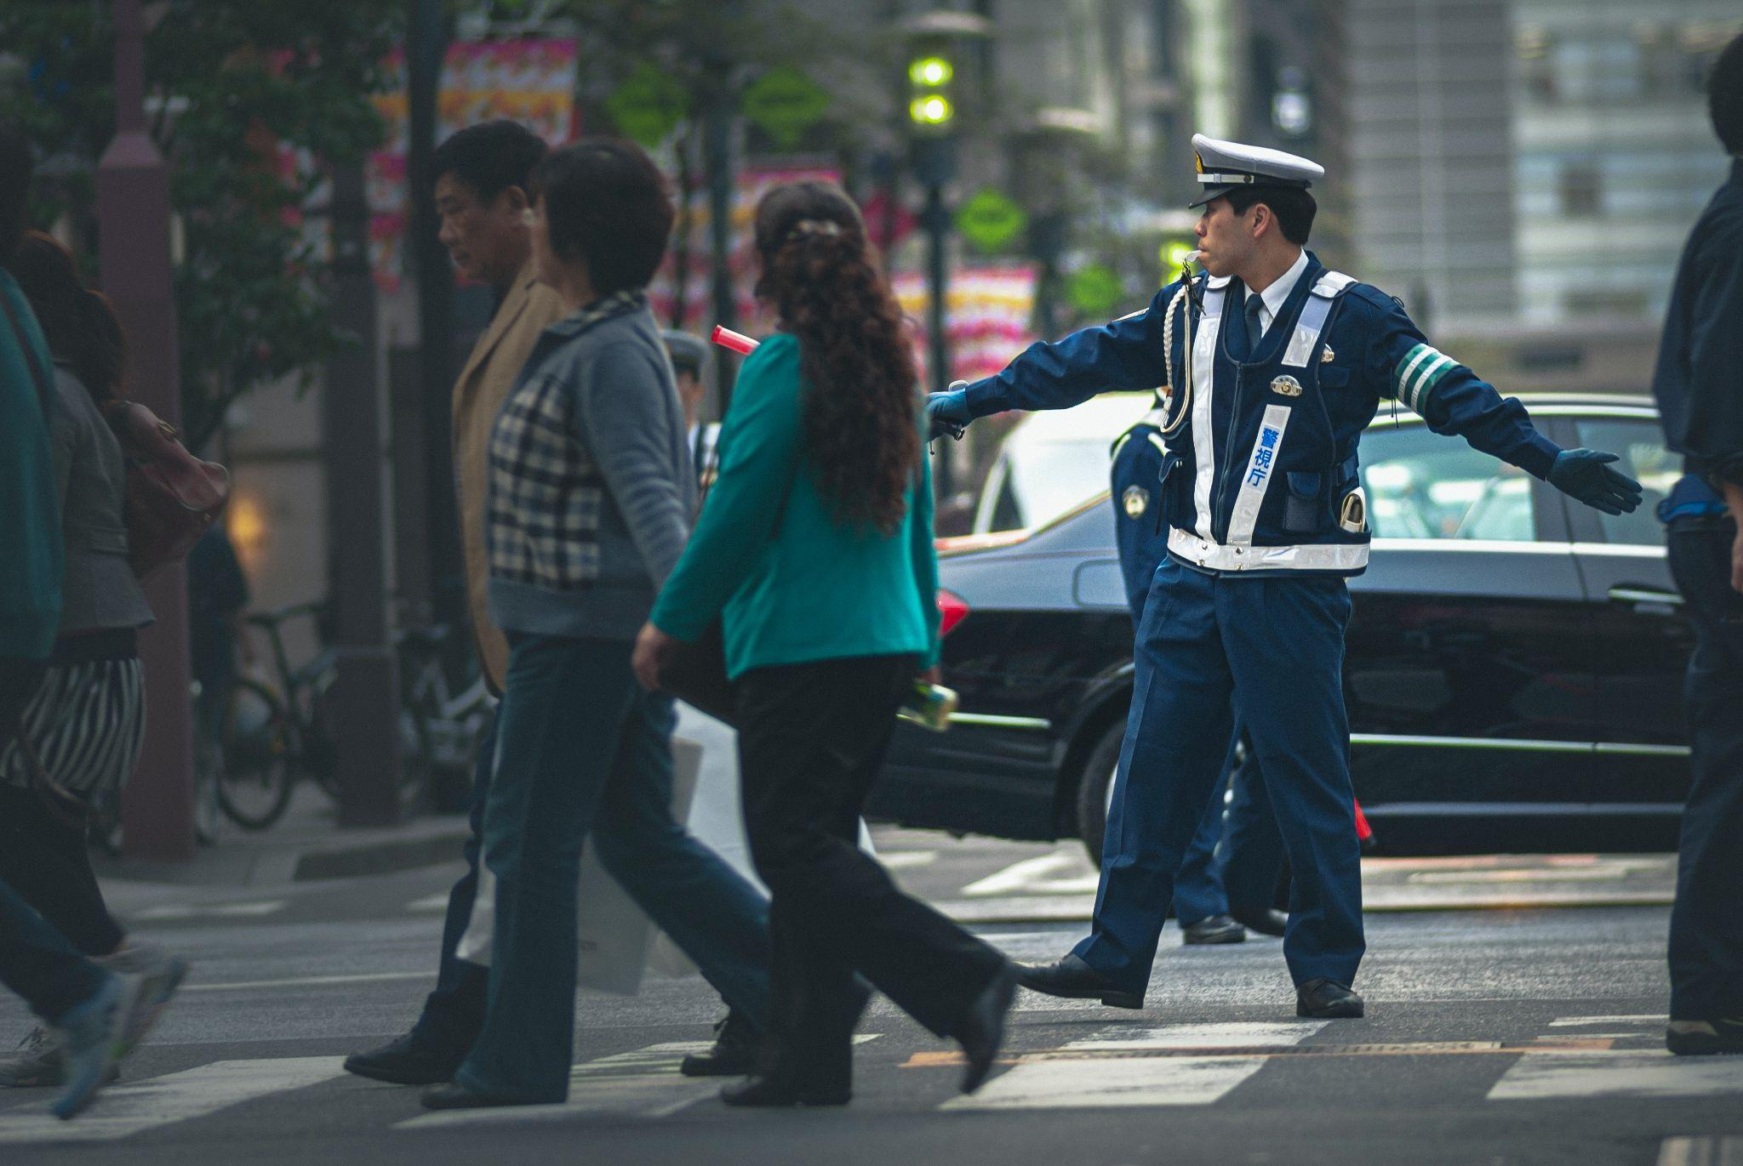 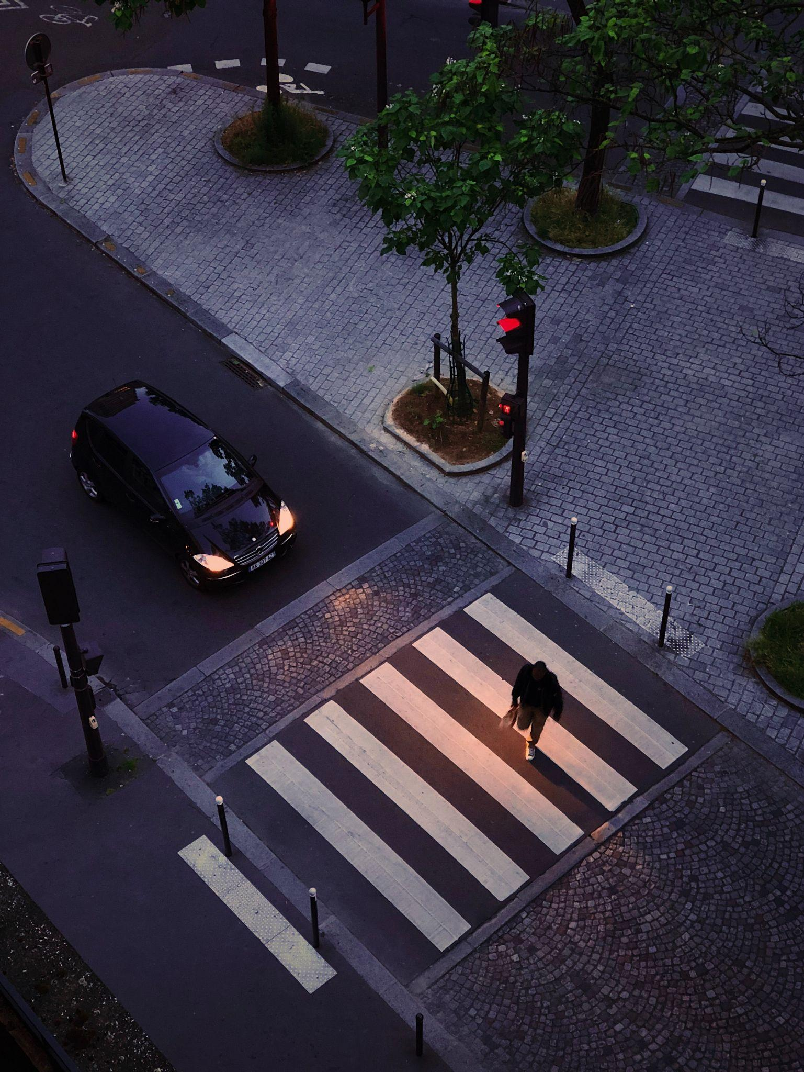

In this fifth and final subsystem, we will be testing the ability of the robot to make decisions based using an IF statement. The robot needs to determine the colour of the traffic light and use it to decide on the appropriate action to perform.

To get started, return to the Create step and start the fifth subsystem. You will then be able to read each of the Research cards, returning to this learning journal to answer some questions at the end of each one.

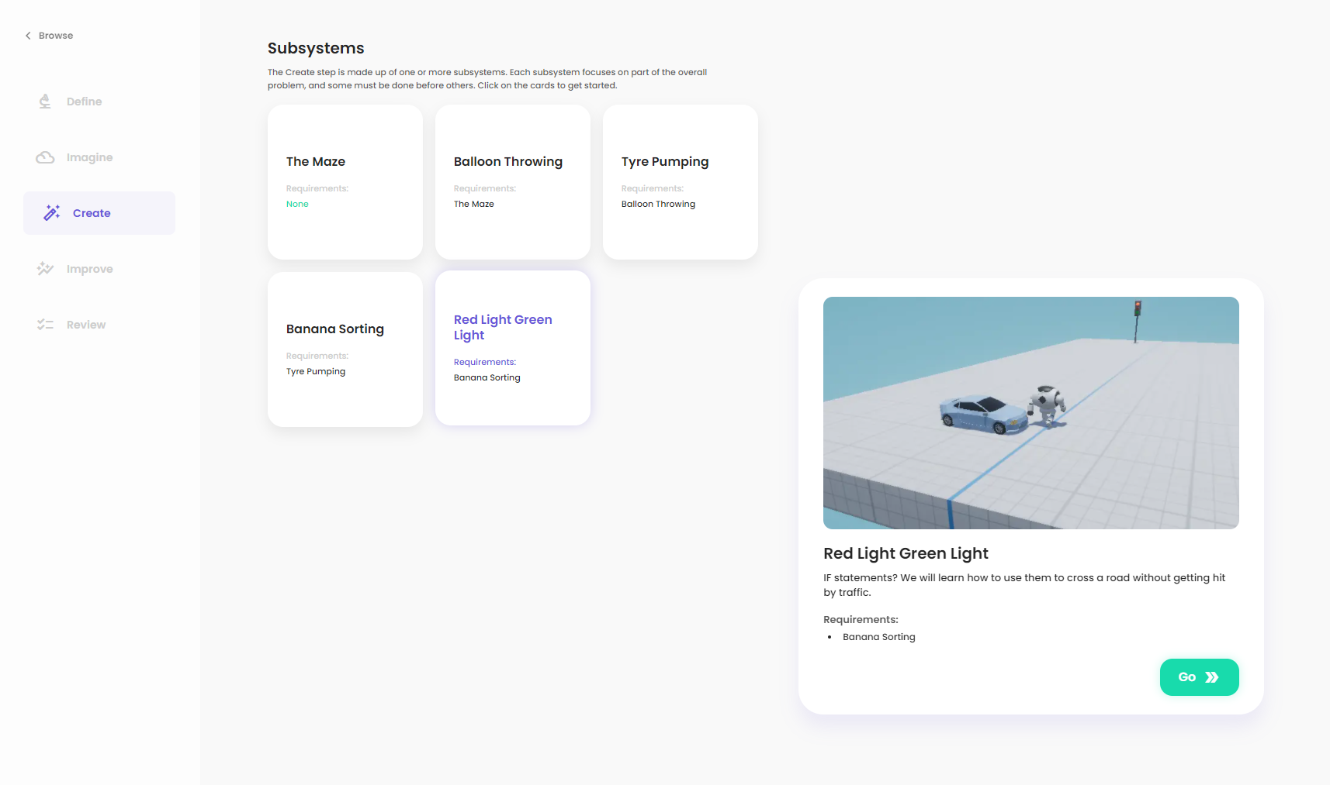

### Research

Read the content in the *Intro to IF statements* card and then answer the following questions. Feel free to discuss the content of the card with your classmates.

1. In your own words, give a brief description of an IF statement.

|  |
| --- |
|  |

Read the content in the *Flow: IF blocks* card and then answer the following questions. Feel free to discuss the content of the card with your classmates.

1. In the microphone example on the platform, what would happen if we pressed compile while our microphone was detecting no sounds? If our microphone started detecting sounds at some point in the future (but we didn't re-compile), what would happen and why?

|  |
| --- |
|  |

Read the content in the *Flow: Comparisons part II* card to learn about two new comparison blocks that may be useful in this subsystem. When you are done, move on to Plan:

### Plan

The traffic light sensor will output either the number 1, 2 or 3.

1. **What should the robot do if the traffic light sensor has an output of 1?**

|  |
| --- |
|  |

1. **What should the robot do if the traffic light sensor has an output of 2?**

|  |
| --- |
|  |

1. **What should the robot do if the traffic light sensor has an output of 3?**

|  |
| --- |
|  |

Continue to the Code step below:

### Code

Return to the platform and create your answer using the simulation inside the Code step. Make sure that you refer back to the Research and Plan content in your learning journal or the platform whenever you get stuck!

To test your program, press the compile button.

When you have finished creating your answer, add a screenshot of your final solution below, showing the success screen and your Flow code. Then, write a brief explanation of how it works, including any problems you encountered along the way and how you overcame them.

Importan**t**: *you can save your Flow code using the save icon () in the toolbar in the bottom left corner of the Flow editor. If you save your code before you leave the simulation, you will be able to continue where you left off when you return by pressing the restore icon directly below the save icon.*

|  |
| --- |
|  |

Congrats on building your solution! You can now move on to the Improve step to try and improve the performance of your code:

<http://app.createbase.co.nz/project/intro-to-programming/improve>

# 

# Step 4: Improve

Add a screenshot of your Improve solution below and a brief explanation of how it works and how you tried to maximise your score:

|  |
| --- |
|  |

# 

# Step 5: Review

Congratulations on completing the Project! Please type your answers to the following questions:

1. How could you potentially improve your solution in the Improve step if you had more time available? If your solution to the Improve step didn’t work, try and explain why.

|  |
| --- |
|  |

1. Think about what you achieved during the Project. What are you most proud of?

|  |
| --- |
|  |

1. Think about the parts of the Project that didn’t go well. List up to **three** of them below. If nothing went bad, think about things you could have done better.

|  |
| --- |
|  |

1. Choose **one** from question 3. Why do you think it didn’t go well? If you were going to redo this Project, what would you do differently to avoid this negative?

|  |
| --- |
|  |